FIVB COMO COMPLETAR
EL PLAY CLEAN
Y
PREVENTION OF COMPETITION MANIPULATION
LOS QUE TIENEN CERTIFICADO PLAY CLEAN EMITIDO A PARTIR DEL 2022 NO DEBEN HACERLO

COPIAR EL ENLACE Y COLOCARLO EN BUSQUEDA GOOGLE
http://playclean.fivb.com/Home/Cultures
lo lleva a
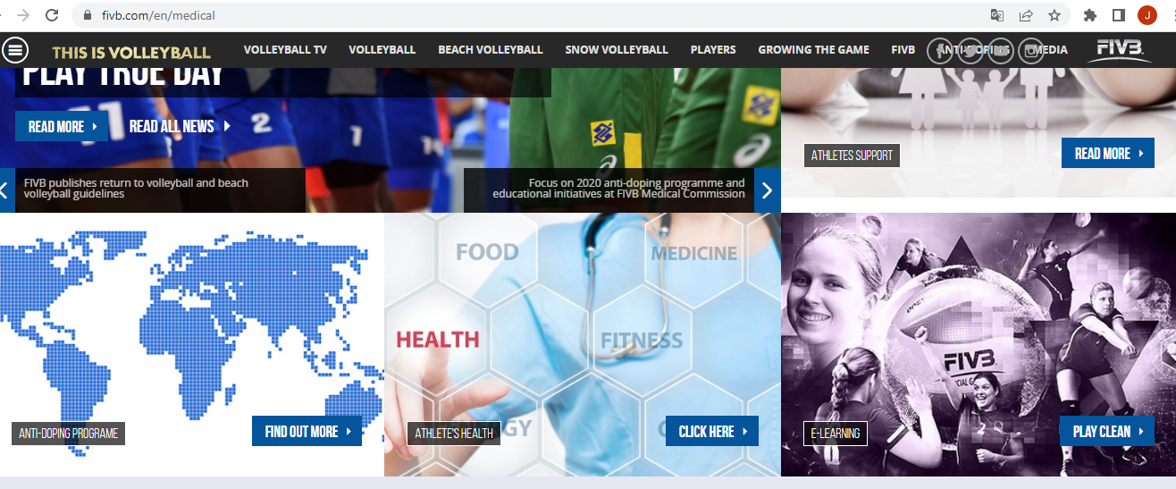
TICLEE EN PLAY CLEAN
Esquina inferior derecha
Y SIGA LOS SIGUIENTES PASOS
Ingresando su username y password
de su cuenta en el VIS de la FIVB
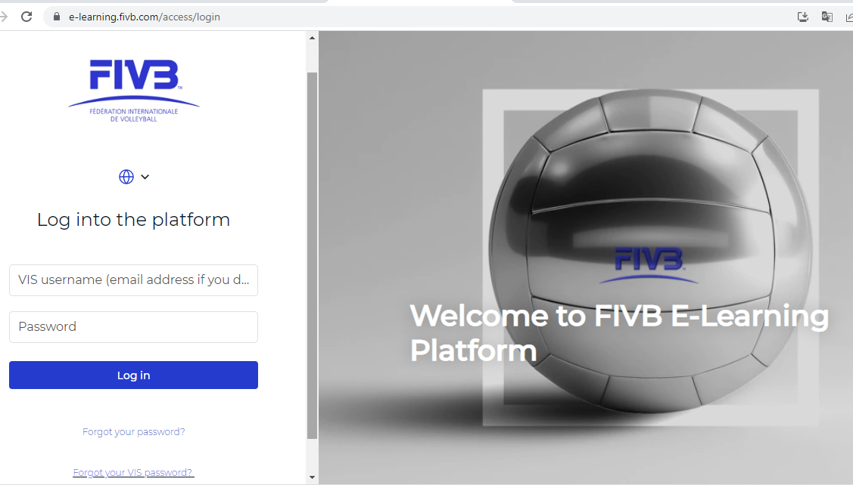

Una vez ingrese a la plataforma del e-learning
Busque los módulos de play clean y competition manipulation y completarlos

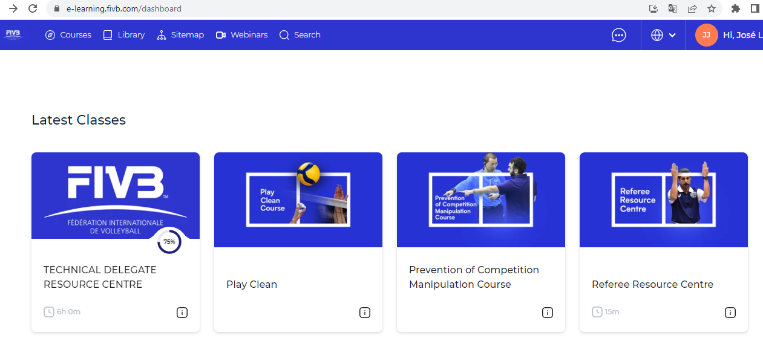

y obtenidos los CERTIFICADOS envíelos a su Federación Nacional para su archivo, guarde una copia del certificado en sus archivos.

FIVB Launches New Play Clean Programme
Anti-doping education tool assists in protecting clean sport and athletes
27/09/2021
The FIVB has launched its new Play Clean programme to equip volleyball and beach volleyball players, referees and support personal with the knowledge to protect the integrity of sport and ensure a level playing field.
The Play Clean programme is an interactive anti-doping education tool, developed together with CSCF & Partners Consulting to inform and educate participants on their rights and responsibilities in regards to anti-doping. The interactive learning experience incorporates lessons and quizzes on a range of topics, and has been updated to fully align with changes made to the World Anti-Doping Code (Code) in 2021.
FIVB President Dr Ary S. Graça F° said:
“The FIVB is committed to ensuring an equal field of play for our athletes by protecting clean sport. We consider education to be an integral part of this, which is why we continue to support the Volleyball Family with educational resources such as Play Clean.
“This free and online education tool ensures that our stakeholders fully understand their responsibilities, so they can play their role in protecting clean sport and the integrity of volleyball and beach volleyball.”
Play Clean is a mandatory requirement for athletes and accredited medical personnel to participate in FIVB and world competitions, and the programme is updated every Olympic cycle, in addition to when major changes are made to the Code.
The programme is hosted on the FIVB Learning Management System (LMS) together with all other online courses offered by the FIVB to its stakeholders.

